PHILOSOPHY
Leadership is a five-year program designed to provide challenges and opportunities to students in the classroom, the community, and in our natural environment. We aim to cultivate students’ ideas, experiences, and passions, and help them find ways to make their aspirations a reality. Throughout the program, students fully participate in a variety of school, community, and outdoor activities. It is through these experiences that students are challenged to be active citizens, develop interdisciplinary collaboration and leadership skills. Students that attend our program are part of a community network that prioritizes social responsibility, environmental stewardship, and community engagement.

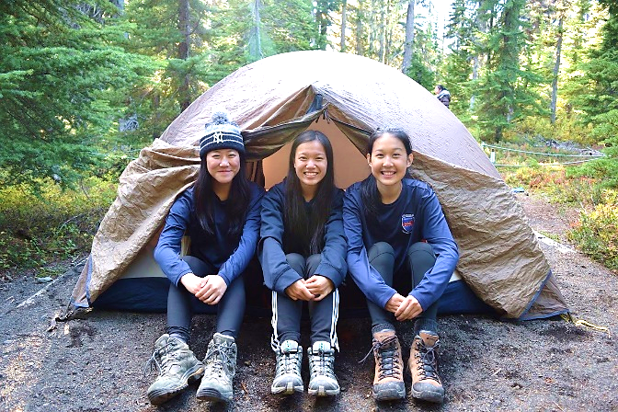

PROGRAM OVERVIEW
The Leadership Program gives students the opportunity to benefit from a mini-school setting while still being involved in the full school community. Classes are grouped so that students attend 4 Leadership-focused classes with their cohort and attend 4 courses with the mainstream Windermere population. Under the semester model, students will attend Leadership classes for 1/2 a day and mainstream classes for a 1/2 a day.

Grade 8
In the 1st year of the program, students combine Science 8, Social Studies 8, Physical and Health Education (PHE) 8, and English 8 in a 4-course Leadership program.

Academics: Leadership courses link classroom learning and real-world learning experiences through community engagement and outdoor education opportunities. For example, students will not just learn about social studies from a textbook, they will experience it through participation in workshops and working with community organizations.

Outdoor Education: Connecting to nature, challenging oneself, and working as a group are key facets of our outdoor education focus. In grade 8 students are introduced to outdoor adventure through hiking and cross-country skiing at Manning Park.

Volunteering: Students develop practical leadership skills by volunteering in the community. Examples of common volunteer projects: the Renfrew Ravine reclamation, the Renfrew Moon Festival, participation in the school garden and orchard, and facilitating arts and athletic programs with elementary schools through our partnership with Windermere Community Programs.

“They are strong conceptually and in challenging group processes. They demonstrate strong leadership skills in a traditional form as well as in a dynamic, distributive manner. Simply put, their experiences and development in the Leadership program puts them ahead of their peers within the faculty, and it is evident in the classroom and evident in the community. They enter our undergraduate degree programs with a level of understanding of the complex connections between food, health, culture and the environment that we aspire to attain for our students by 3rd or 4th year.” –Dr. Will Valley, Instructor in the Faculty of Land and Food Systems at the University of British Columbia
OUTDOOR EDUCATION
Outdoor education and community engagement are core components of the leadership program. Students are selected based on the understanding that participation in community events and camps is essential. Camp equipment is supplied to all students and an annual outdoor education fee of $35 is collected at the beginning of every school year to cover the costs of maintaining this gear. Additional trip fees will apply throughout the year depending on the camp.

SO WHY JOIN?
- Students develop leadership skills like event planning and promotion, workshop facilitation and interpersonal communication.
- Students actively engage in social justice and environmental stewardship both in the classroom and in the community.
- Students gain confidence and improve their fitness through outdoor adventure challenges.
- Students benefit from a small mini school setting without losing the opportunities of a large school.

The Leadership Program seeks candidates who are hard-working, motivated, and dedicated to creating positive change in themselves and their community.
If that is you, please get in touch and consider the Windermere Leadership Program!

Find us at www.windermereleadership.org
or email prempel@vsb.bc.ca

We hope to see you at our info night session on November 5, 2021:
GRADES 9-12
Grade 9 Highlights
- Cross country skiing at Manning Park trip
- Volunteering with the school garden and orchard as well as Windermere Community Programs
- Ecology 9 offers specialized education combining social justice & environmental stewardship.
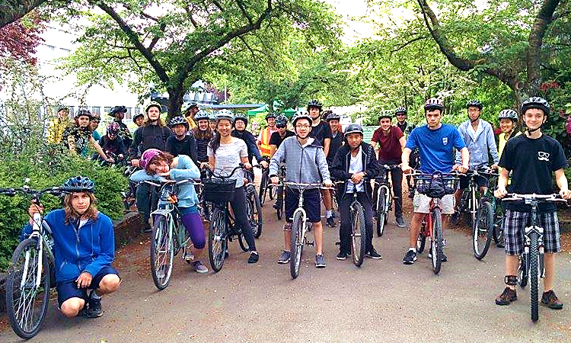

Grade 10 Highlights
- CLE 10 is a specialized course which teaches skills like group facilitation, event planning & promotion, communication, and grant writing. The course also focuses on social justice and environmental curricula.
- Students take on leadership roles in programs like the Renfrew Ravine Moon Festival.
- Out trips often include a 3-day hike in Joffre Lakes Provincial Park, a 4-day cycling trip on Galiano Island and cross-country skiing at Manning Park.
Grade 11
- In Environmental Science 11 and in History 12 students further their social and ecological justice knowledge.
- Students are supported as they organize ambitious community events such as the Vancouver Earth Day Parade and the Windermere Car Free Day.
- Grade 11s become true leaders who organize many important school programs and projects with support from teacher mentors.
- Trips often include a 3-day hike in Garibaldi Provincial Park and a 4-day cycling trip to Salt Spring Island.

Grade 12
- Students develop their own independent leadership projects in CLC 12 with mentorship from teachers and community partners. Past projects have included organizing Car Free Day, editing an online newspaper, managing the school garden, and coordinating the school’s team of emergency First Responders.
- Students may choose to take Outdoor Education 12 as well to further develop their repertoire of outdoor experiences
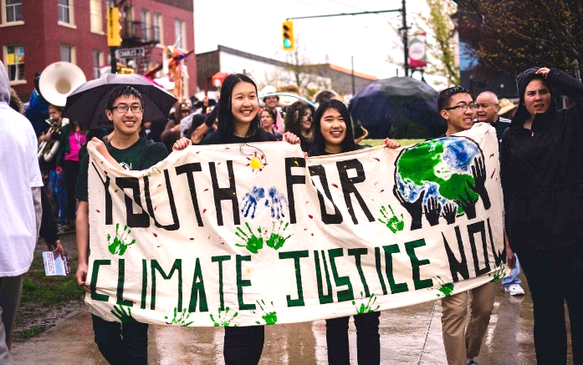

WINDERMERE LEADERSHIP PROGRAM

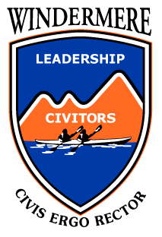

“Know the way, go the way, show the way.”

www.windermereleadership.org

“Due to my strong desire to improve myself, my love for the natural world and my eagerness to broaden my perspective, I joined the Leadership Program and it’s a choice that I’ll never regret. Through this program I’ve met many inspiring young leaders and received opportunities that I wouldn’t have encountered otherwise. My wish is to continue growing so that I can use what I’ve learned to help those without a voice and bring our global community closer together.”
-Katie Wan, Class of 2019

